Lab # 01



Fall 2024

**CSE-411L Intro to Game Development Lab**

Submitted by: MUHAMMAD SADEEQ

Registration No.: 21PWCSE2028

Section: C

“On my honor, as a student of the University of Engineering and Technology, I have neither given nor received unauthorized assistance on this academic work”

Submitted to:

Engr. Abdullah Hamid

(27 Oct 2024)

Department of Computer systems engineering

University of Engineering and Technology, Peshawar

1. First I install the Unity Hub
2. In the Unity Hub, I installed Unity Editor, Visual Studio and Android Support.

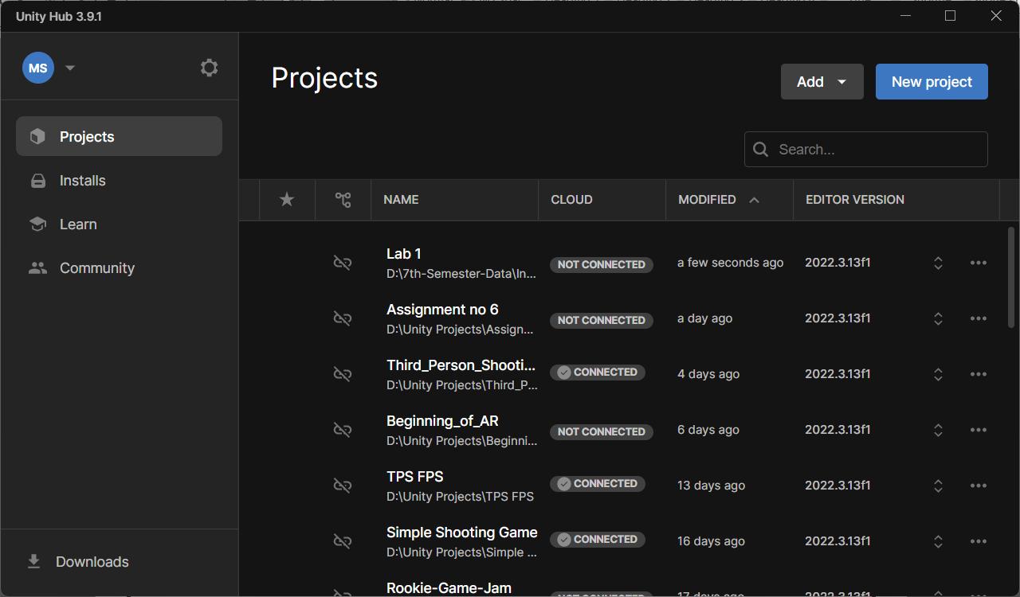

1. I created project in Unity Hub with the name Lab 1
2. I open the Lab 1 project



1. First I changed the Editor Layout set it from Default to 2 by 3
2. In the Project Panel I change the Layout to One column Layout
3. I create all 3D objects in the Scene View and Set the camera to face them
4. I changed the Direction light Rotation to get Different Shadows of the 3D objects.

